
December 2024
Frank Russo, Editor

Our Day Begins – Here Comes the Sun

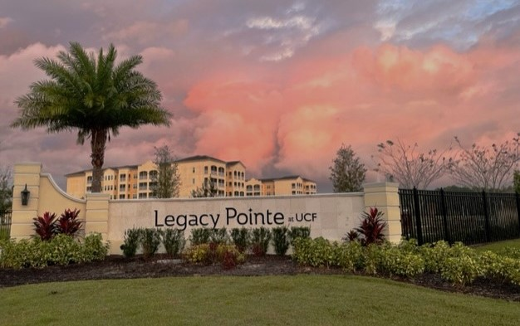

By Dona Hams

Well, this month one picture did not see the Sun
Instead saw SNOW . . . AT "LEGACY"?

For many of our family members who have come from the north, and with our hopes of you’re not getting/becoming homesick . . . imagine if you will - - - this is what "LEGACY" would look like if we had a light dusting of snow on the ground.

Now, aren't you happy you're in FLORIDA??
Commentary by Vicki Tindall



These photos were taken with an infra-red camera by Jim Lau

Feature Article on Christmas



The two competing personages at the Christmas Season

When did their paths cross?

Who will history remember?

Each year we hear from various church and social groups to “Put Christ Back into Christmas”. Well with me that raises two questions: First: “How did Christ ever get put into Christmas” and Second: “Did He actually leave it”
Let’s look into the little history as we know it from what is actually recorded. In the scripture: Joseph, Mary, and their son had a real rough start to life. The traveled many miles to Bethlehem and ended up in a cattle barn for lack of any other accommodation.
The decision to celebrate Christmas on December 25 was made sometime during the fourth century by church bishops in Rome. The church leaders in Rome decided to celebrate Christ's birth during the winter solstice in an attempt to Christianize the popular pagan festivities that were celebrated by many Romans.
And so, it remained as the celebrated date of Christ’s birthday and eventually the pagan solstice faded into the background.

From then until now the December 25th motif was reinforced by the AI people of their time (Artist Imagineers). These AI devotees came onto the stage long before today’s high-tech world. These artists painted masterpieces from their imagination and gave to the churches a strong reinforcement of the ‘Christ in Christmas’ message.

And so, for 19+ centuries, Christmas was celebrated as a religious event. But in the early 1930s there was a new challenge to the December 25th event. For about seventy-five years before the 1930s there were stories and rumors of a new actually ‘old’ kid in town named ‘Santa Claus’.
It was Coca Cola that gave a final form and costume in their ads at that time. They were the new AIs. They clothed ‘Santa’ in his red outfit and gave him an attractive face and personality. They were twentieth century commercial imagineers. And their product caught on like wildfire.
So, what’s in the future? Well Joseph and Mary’s son has quite a few centuries in the spotlight and has withstood many crisis situations. Santa has only been around for less than a century but has accumulated quite a following.
The ‘son’s’ message is “Come follow me”. Santa’s message is “Give me your VISA”. I wonder which is the most attractive.

EARTH DAY IS REALLY 365 DAYS – Our Monthly Reminder

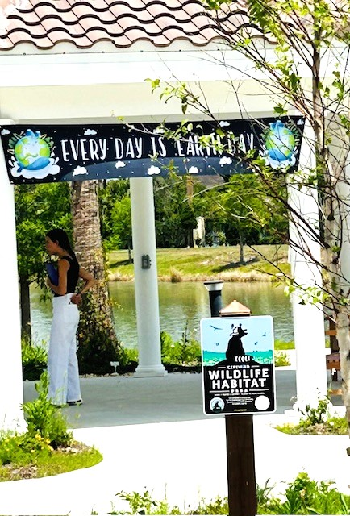
Photo By Maureen Reed

The Theme for Earth Day 2024 is “Planet vs. Plastics”
Starting with Earth Day 2024 the LP Independent Times has been focusing on the theme for this year “Planet vs. Plastics”. We have all seen pictures of piles of plastic in every form littering our landfills, our waterway, and in every trash pickup worldwide. We are being buried in plastic.
This is serious. Governments and businesses for decades have stressed recycling and reducing our dependence on plastic. They fail to tell the people of the world that 93% of plastic is not recycled because it can’t be and there is very little use for the small amount that is recycled.
But as the LP Independent Times has been discovering in its editorials, there is a dangerous combination of chemicals in plastic called PFAS. They are called forever chemicals which

means that they can never be broken down. Currently there are over 15,000 combinations of these chemicals in today’s manufactured products. And they remain forever.



AND they are invisible. We can see the piles of plastic trash which is an eyesore. Forever chemicals, the remaining residue of plastic products, are invisible except under special microscopes. The larger particles are called micro-plastics. The invisible particles are called nano-plastics. Wherever there is plastic there is a residue of nano-plastics.
This means that in our homes wherever anything has any of the 15,000 combinations there is a serious shedding of plastic particles. Most of our carpets have some of these composites. Our clothes, towels, and bedding have some mixture of nylon, rayon, etc. mixed in with our cotton. Cleaning products, personal care items, kitchen utensils are all contaminated.
Where do we start to do anything? First read the labels on products. If you don’t understand the contents, then it could be PFAS.
But how does it get into my home. I don’t leave piles of plastic lying around to decay. Correct! Did you ever take a pair of slacks off the clothes hanger, hold it in front of you, then shake out the wrinkles. If yes, you have just released thousands of nano-plastics into your home. And we do things like this hundreds of times a day.
Next month we will discuss simple steps that you can take now to reduce the release of nano- plastics into your home. In future issues we will investigate what science is finally learning about PFAS chemicals and where they can be found.

Microplastics Are Infesting Clouds, Affecting Weather
In a press release, Penn State says that its environmental researchers have found evidence that microplastics may help in the formation of the ice crystals around which rain droplets form, essentially "seeding" clouds unintentionally.
Published in the journal Environmental Science and Technology: Air, this new lab-based study saw Penn State researchers place four different types of microplastics — low-density polyethylene (LDPE), polypropylene (PP), polyvinyl chloride (PVC) and polyethylene terephthalate (PET) — in small droplets of water, allowing them to cool slowly to see how they affected the freezing process.

See the Link below for the full story

https://futurism.com/the-byte/microplastics-clouds-affecting-weather

RECYCLING A REPORT ON RECYCLING AT PUBLIX
Sharon Lovell’s article see link below

Publix encourages customers to make the right choice and use reusable bags, but for those customers who choose plastic or paper, we provide recycling bins so they’re properly recycled. By inspiring customers to recycle these items, we ensure they are disposed of properly and kept out of the environment and landfills.
We focused on reducing waste long before ‘Eco savvy’ was chic. As early as the 1970s, we began formalizing recycling by collecting all cardboard from stores and working with paper companies to recycle.
Each year, our goal is to improve our recycling practices.
Other ways we’ve saved.
In 2019, we began working with a facility that accepts hard-to-recycle materials and turns them into fuel cubes that are a cleaner alternative to coal. This process has allowed us to divert more than 31 million pounds of materials such as contaminated cardboard, paper, and plastic from the landfill.
In an effort to reduce plastic waste, we work with a milk crate recycling service to recycle broken or damaged crates into new crates. Since we began tracking this effort in 2018, we’ve been able to recycle 565,346 crates equaling 1,413,366 pounds of plastic saved.
Awards and recognition.
In 2022, we were recognized as a Recycling Champion by the Florida Recycling Partnership Foundation. Judges from the University of Miami’s Sustainable Business Club named us Best Overall for our work in landfill diversion and sustainability communication and education.

For more information use the link below to read the full article
https://csr.publix.com/recycling-at-publix/

Veterans Day November 11th



Veterans Day was observation quietly this year at Legacy Pointe. Flags were placed throughout the grounds. Reminders were posted throughout the building and Veterans events in the local area were posted and a number of residents attended these events.

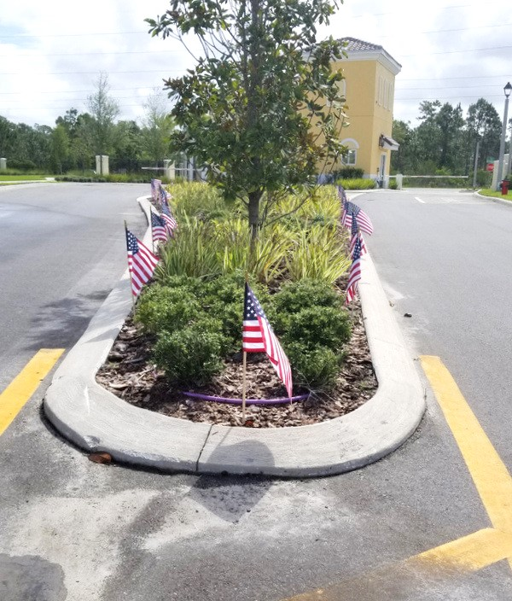

TRAVELLING
Clare and Wes Pollard have submitted a website of trips from Roads Scholar which is offering a series of travel lectures given by experts in their fields. These lectures – some of which are free – are for those who are planning to travel or who have already travelled.

The lecture runs for about an hour to two hours, depending on how many questions there are. If you can't make the date listed, sign up and they email you a recording of the lecture which is good for two weeks after the lecture date.
Below is a link to the website for future information
https://www.roadscholar.org/collections/online-lectures/free/?e_id_s=4566afc4a7d54669c1e0002536025035d68e3744d440660eda7da3fd8d8b8dec&utm_source=Email&utm_medium=MktEmail&utm_campaign=ESK25&utm_content=FL&RID=3f3d007c396067dcc6b2a3b32c461ddb

Next Roads Scholar Lecture at a Glance
Join Andrew Eungi Kim, Professor of International Studies at Korea University, for an engaging exploration of Korean culture using a framework of five essential keywords. With so many elements to consider, understanding any culture can be challenging, and Korean culture — with its rich history spanning thousands of years — is no exception. This lecture will use these five key concepts to illuminate both familiar and lesser-known aspects of Korea’s cultural identity, offering a structured approach to this complex and fascinating topic.
General Notes
Your online lecture will take place live over the course of 1-2 hours. All times are listed in the EASTERN time zone. If you live in a different time zone, please adjust your schedule accordingly. This live online experience uses Zoom Webinar, an easy-to-use web video service that includes closed captioning. All you need is an Internet connection and your computer. You will receive a confirmation email when you enroll, and a reminder email one week and one day before, as well as the morning of the event with a link and instructions on how to tune in. You will not be pictured on screen during the lecture, but you will have the opportunity to ask the instructor live questions using the Q&A box. Unless otherwise noted, all those who enroll in this program receive access to the live event as well as a recording of the lecture that you can watch any time within the two weeks following the live event.

Resident Employee Appreciation Fund

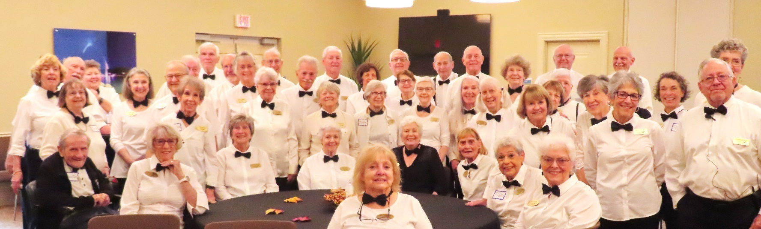
The Residents who served the employees photo by Vicki Tindall

The residents of Legacy Pointe showed their appreciation to the hourly employees who service the residents living in the different units of Legacy Pointe. According to the Chairs of the REAF committee the total dollar amount raised for the employee hourly pool was $186,887.18. About 200 hourly employees were eligible to participate.

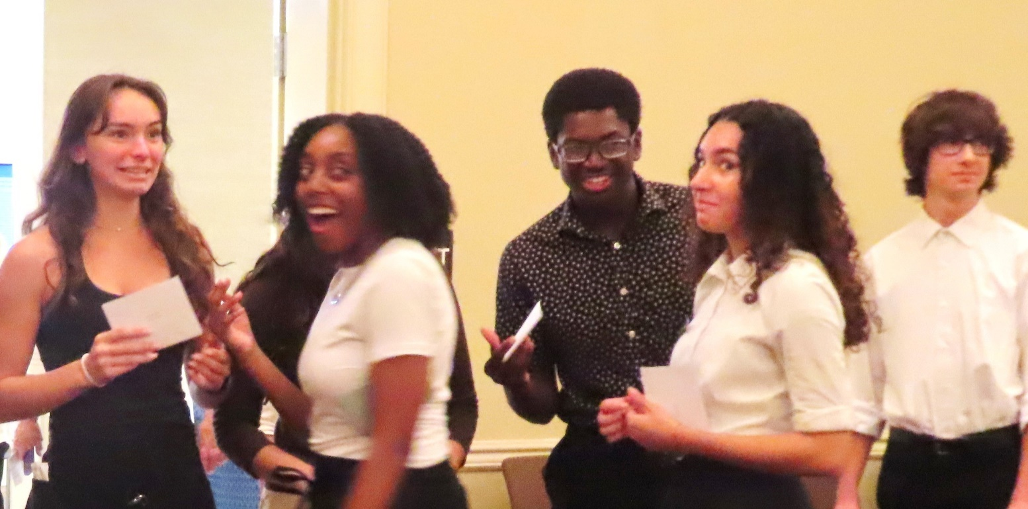
The celebration took place on November 20th starting at 3 PM in the Auditorium. Employees arrived in shifts for food, snacks, and drinks. Reserved tables were filled and refilled every 20 minutes. Formal festivities started at 4 PM at which point residents joined in the celebrations.
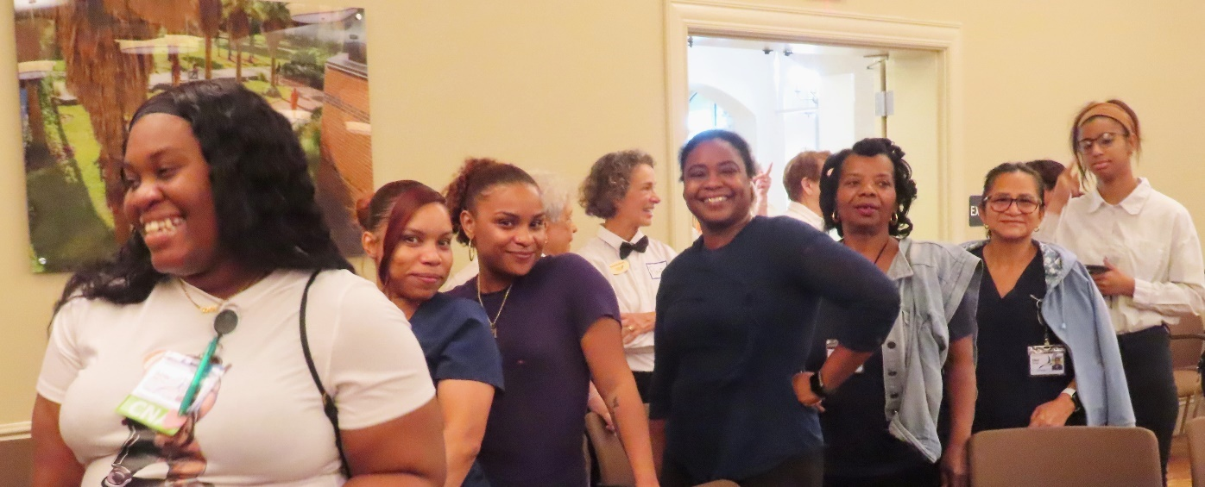

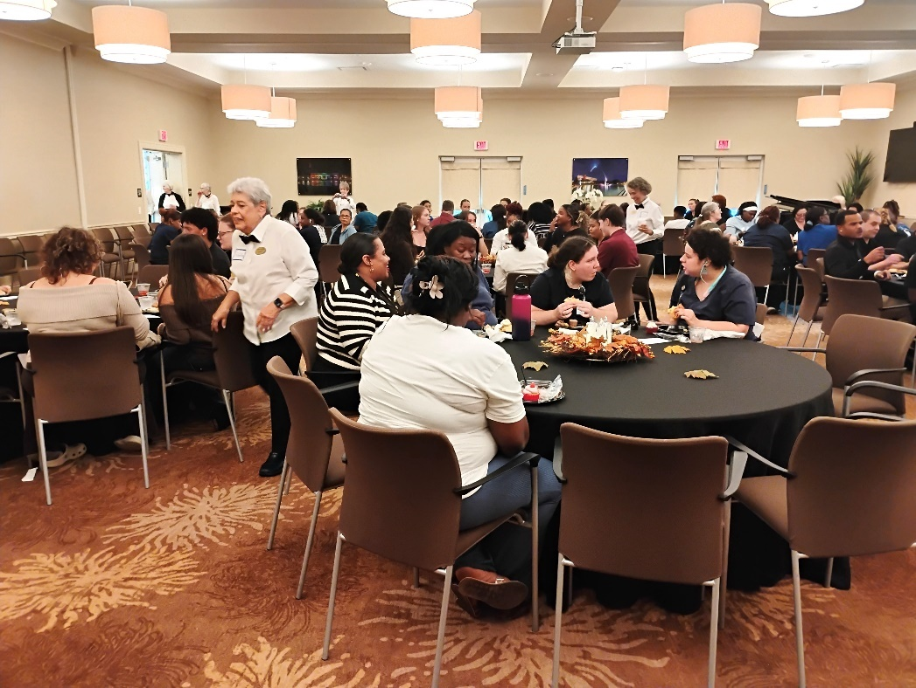

By 5 PM the Auditorium had emptied and it was time for the servers to take a break

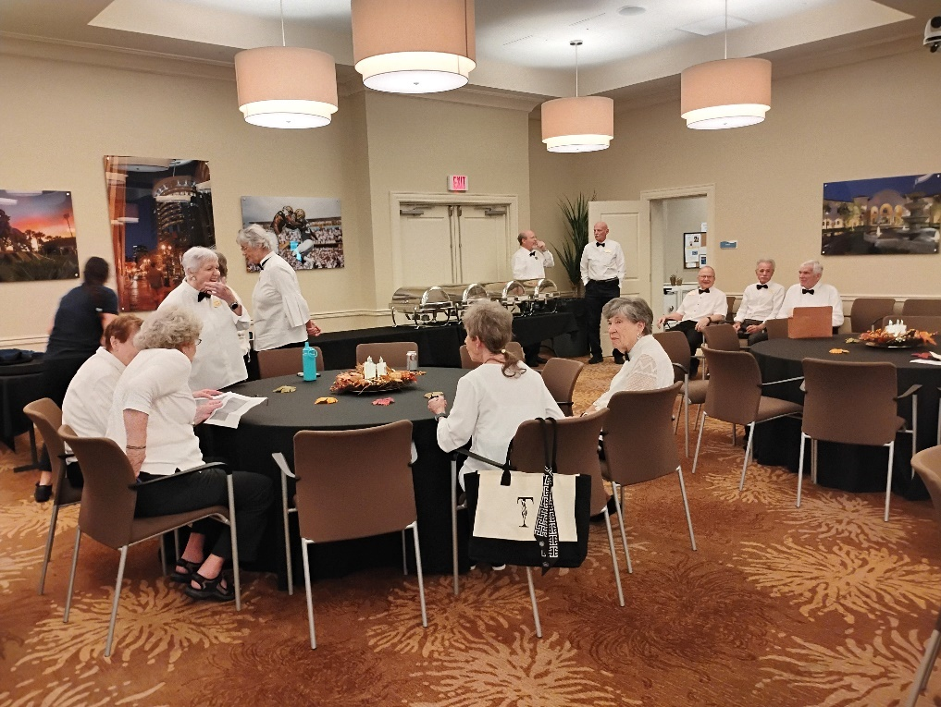

Home for the Holidays

The Orlando Philharmonic Orchestra had their anual Home for the Holidays Concert on Saturday November 30th. Residents filled the L.P. bus and a number of other residents drove themselves. The seats in Steinmeitz Hall were filed to capacity. And Santa made a guest appearance.


Some Legacy Pointe residents stopped to get their picture taken with Santa.


Thanksgiving at Legacy Pointe
If you stayed for dinner on Thanksgiving Day you were treated to a menú that was a gourmet delight. The dining room was packed with residents, family, and friends. Very nfew wanted to leave the tables because the buffet was calling everybody back for another helping

Festival of the Trees

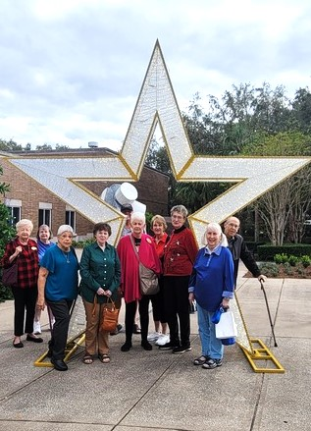

On November 18th residents of Legacy Pointe boarded our bus to head to the Museum of Art for the Fetival of the Trees.

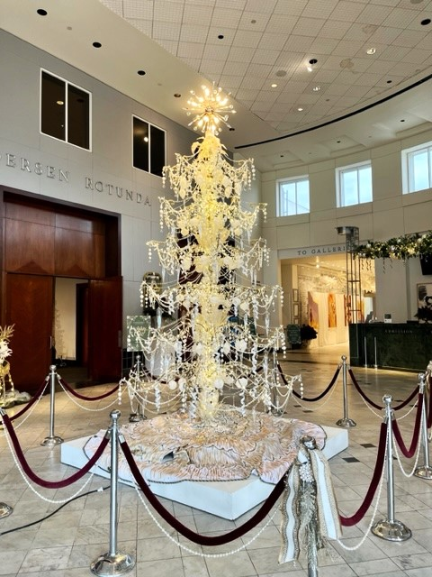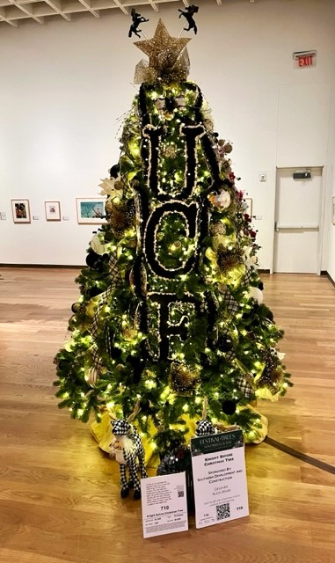

Photos by Dona Hams

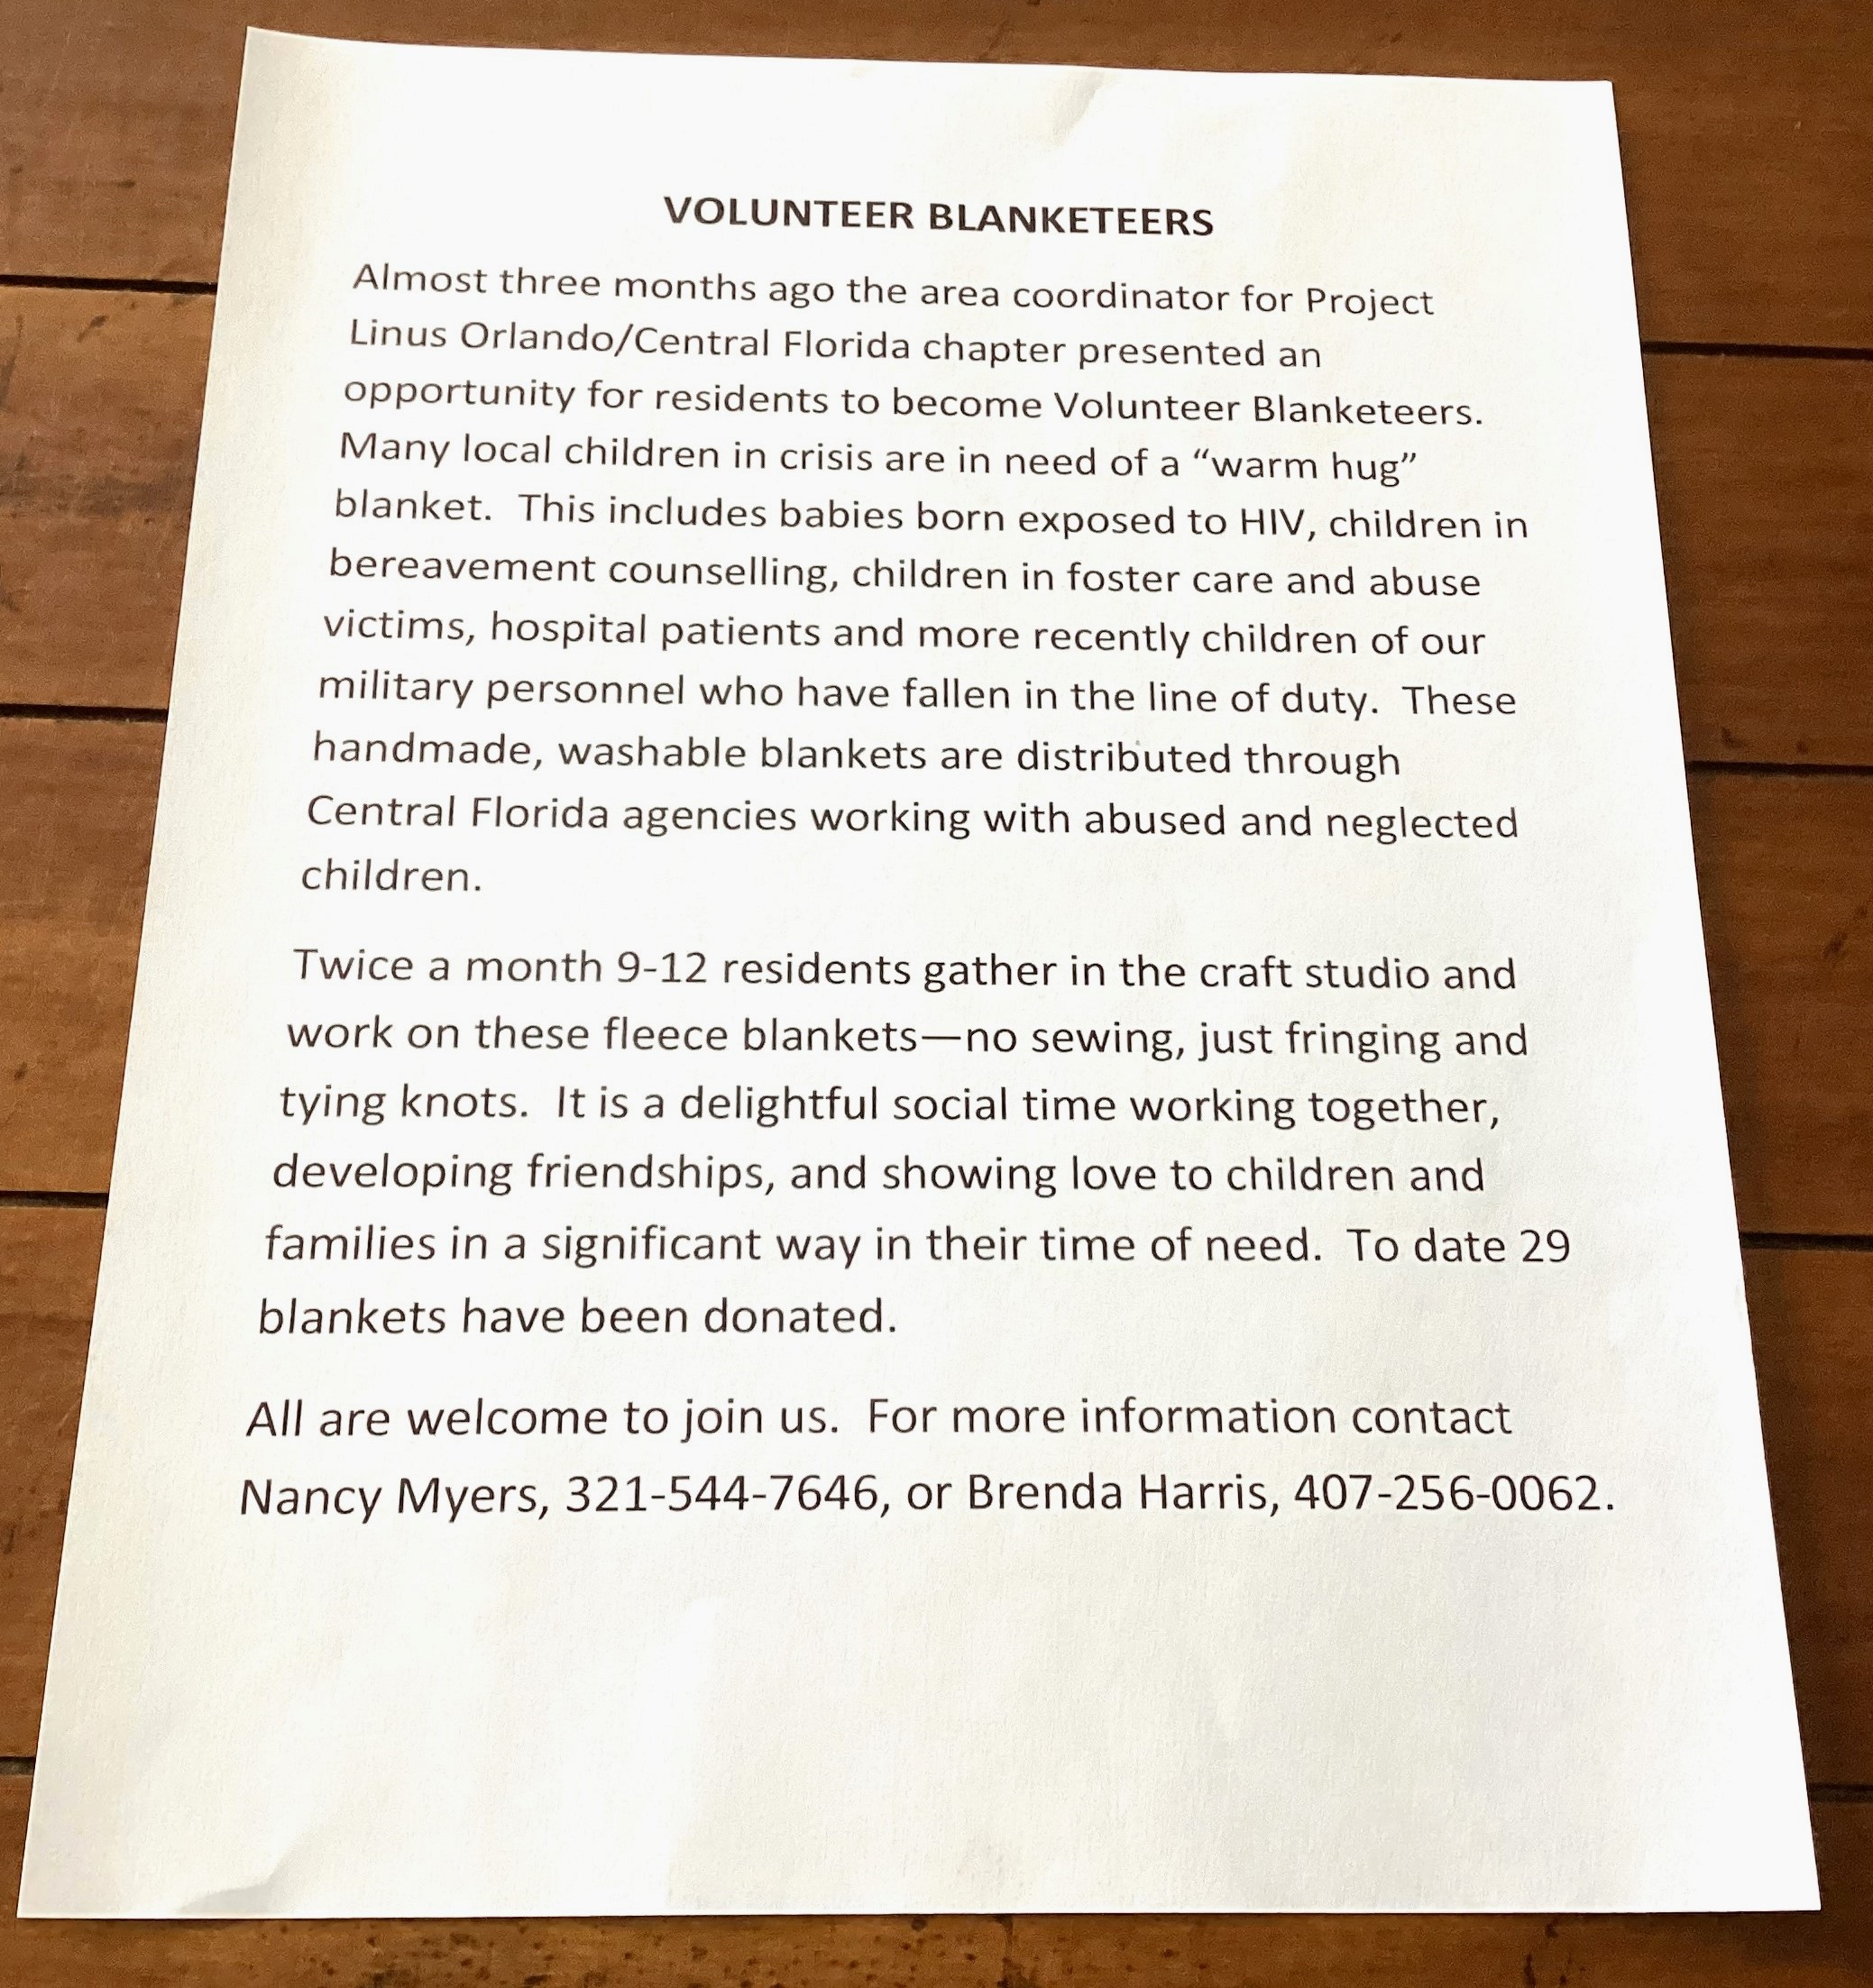

The Blanketeers meet twice a month contact
Nancy Myers 321-544-7646 or Brenda Harris 407-256-0062

BOCCE
bŏch′ē

Bocce is a game of Italian origin similar to lawn bowling, played with wooden balls on a long narrow court covered with artificial turf or fine gravel.
The number of residents who are interested in Bocce are growing dramatically. Gary Cobb and Bill Malfitano are conducting regular “Introduction to Bocce” sessions on a weekly basis. Check the sign up sheets in the Villa ‘cubby areas’ across from the main floor restrooms for a complete schedule. And then come out and play Bocce.

OUR INTELLIGENCE (OI) versus ARTIFICIAL INTELLIGENCE (AI)
The Fourth AI Level by Frank Russo

For the last three month we talked briefly about Artificial Intelligence (AI) A brief definition taken from Tromenz Learning: “AI, short for Artificial Intelligence, is composed of 2 words, Artificial and Intelligence, where Artificial defines something as “machine-made,” and intelligence explains “thinking power”; therefore, AI merely means “a thinking power which is machine-made.”
Level One – referred to as ‘Narrow or weak AI i.e. limited to specific tasks
First at Level One there is the ‘text in and text out’ or ‘word in and word out’ levels. An example of the ‘word to word’ level is something we probably have used. We have asked ‘Alexa’ or ‘Siri’ a thousand questions.
At this level human OI (Our Intelligence) tells AI “Here is what you need to do and here is how you do it.
Level Two - Often called General AI is still directed by OI but AI can begin to analyze data and is at the beginning of a learning curve
Even at level 2 human OI (Our Intelligence) is the developer of computer software to perform the ‘task’. So, we have left the ‘word to word ‘level and have entered the ‘action level’. This action phase has a level of complexity calling on science to design the ‘tools’ that will be used by the computer to perform a task.
Wow what a challenging task for (OI). Every variable must be considered, and each algorithm must be tested. (OI) is still in charge but AI is starting to come on strong.
Level Three - AI is learning to play chess at Level three. OI is no longer programming AI to play chess but rather is creating an AI that can learn to play chess. But for now this advanced AI is still a scientific dream at level three.
ChatGPT was introduced by OpenAI in November 2022, ChatGPT has dominated the stock market and technology. It is moving along with its ‘learning’ potential and different output results. It is starting to think at one particular process. It is going beyond self-driving cars. But it cannot think beyond itself. It cannot apply its ‘car learned’ experiences to driving a motorcycle.

Level Four - This month we will look at Level Four and go far beyond. This level is sometimes called ‘artificial general intelligence’. Level Four is used here to include additional levels five, six, and seven. And who knows how many new levels we will add in the future. But that is beyond the scope of this article.
At this level AI has achieved in some areas a degree of “artificial general intelligence”. But it needs to go further. It needs to perform day-to-day activities that most humans can do. For example, AI at level three, is close to creating self-driving cars. So, let’s push the analogy further. A human child can learn to ride a tricycle. Later it can figure out how to ride a bicycle, then maybe how to ride a motorcycle, then drive a car, then drive a speedboat. All these activities have a learning curve and a transfer of knowledge to other areas involving previously achieved skills.
Next month we are going to take off into the world of ‘sci-fi’ or maybe it won’t be Science Fiction but AI will become II (Intergalactic Investigation).

TECH CORNER
by Joe Solymossy

During last week’s Life Styles Committee meeting, we discussed the future of the
Legacy Pointe University. Today, I am going to start the introduction of the next
evolution of the Legacy Pointe University.
This past two years I have presented classes on the use of various computers, tablets, cell phones and iPads. More recently, we included discussion on computer security and passwords as well as effective use of email. Earlier in the year we were mesmerized by Mitch’s discussion about the issues between China and Taiwan, and the ongoing territorial claims by China to the South China Sea..
Starting in January 2025 Legacy Pointe University will present a 45-minute presentation on a subject of interest to many of our residents. I am working with a group of us (we welcome more help), who will schedule a different presentation each month, January to November. We will start by scheduling the first quarter, with the first session being on the subject of technology, the second on World affairs, and the third subject yet TBD.
Our plan is to have a schedule with the presenter and a short description of the presentation available before the start of each quarter. This would allow you to schedule the event before your calendar gets too full.
We are open to suggestions for topics and presenters. Do you have a passion that you want to share with the rest of us? Did you travel to, or live in a country that many of us know little about? Did you know, live with or work with someone we would like to know? Was your job so secret that you could not talk about it, but now you can? Come talk to me. Let us see how we can get you on the agenda.
Joe Solymossy 321-318-2701/ lpjmsoly68@gmail.com

LET’S GO TO A MOVIE!
Here are the Legacy Point Movies for December 2024 and January 2025
UniGuest Activities provides a plot summary of each film. Movies are shown in the Auditorium.
Date | Time | Movie | Year | Run Time | Host
Sunday, 12/8/24 | 6 | Best Exotic Marigold Hotel | 2011 | 2h 4m | Minerva
Wednesday, 12/11/24 | 10  12  3:30 | Holiday Inn  A Christmas Carol  It's a Wonderful Life | 1942  1938  1946 | 1h 42m  1h 09m  2h 10m | Linda Rude  Linda Rude  Bill Weise
Sunday, 12/15/24 | 6 | My Cousin Vinny | 1992 | 2h | BW or Minerva
Tuesday, 12/17/24 | 2 | Movie Committee Meeting
Wednesday, 12/18/24 | 7:30 | Love in Portofino - Andrea Bocelli | 2012 | 1h 26m | Bill Malfitano
Sunday, 12/22/24 | 6 | Die Hard | 1988 | 2h 12m | Bill Weise
Sunday, 12/29/24 | 6 | The Miracle Worker | 1962 | 1h 46m | Minerva
Sunday, 1/5/25 | 6 | Hatari | 1962 | 2h 37m | Vicki Tindall
Monday, 1/6/25 | 2 | The Time Machine | 1960 | 1h 43m | Bill Weise/Clare
Sunday, 1/12/25 | 6 | To Kill a Mockingbird | 1962 | 2h 09m | Linda Rude
Wednesday, 1/15/25 | 7:30 | Simon and Garfunkel - NYC Central Park | 1982 | 1h 28m | Bill Weise
Sunday, 1/19/25 | 6 | Double Jeopardy | 1999 | 1h 45m | Linda Rude
Tuesday, 1/21/25 | 2 | Movie Committee Meeting |  |  | Bill Weise
Sunday, 1/26/25 | 6 | True Lies | 1994 | 2h 21m | Bill Weise
And The Movie Winners Are … Here's the latest winners:
Maria Delaroza - guitar tree ornament for " Neil Diamond Concert NYC"
Riley Reinhard - platter for " Four Weddings and a Funeral"
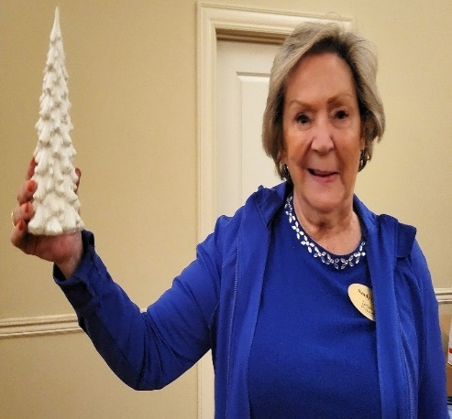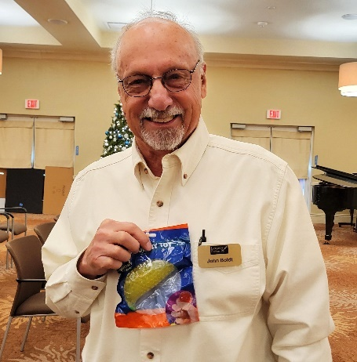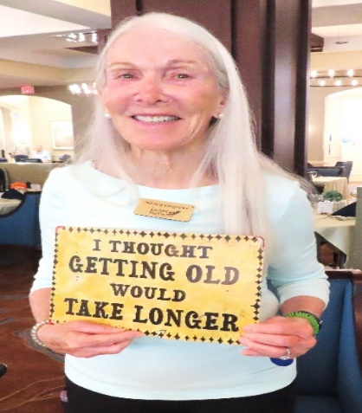
Sandy Clifton White Christ John Boldt The Blob Nancy Cosgrove Cocoon
UCF FINAL 2024 FOOTBALL SCORES
Date | Time | Opponent Score
Thur., Aug. 29 | 7 p.m. | home New Hamps W 57 - 3
Sat., Sept. 7 | 6:30 p.m. | home S. Houston W 45 - 14
Sat., Sept. 14 | 7:30 p.m. | at TCU* W 35 - 34
Sat., Sept. 21 | -- | OPEN
Sat., Sept. 28 | TBA | home Colorado* L 21 - 48
Sat., Oct. 5 | 6-8 p.m. | at FL Gainesville L 13 - 24
Sat., Oct. 12 | TBA | home Cincinnati* L 19 - 13
Sat., Oct. 19 | TBA | at Iowa State* L38 - 35
Sat., Oct. 26 | TBA | home BYU* L 37 - 24
Sat., Nov. 2 | TBA | home Arizona* W 56 - 12
Sat., Nov. 9 | TBA | at Arizona State* L 31 – 35
Sat., Nov. 16 | -- | OPEN
Sat., Nov. 23 | TBA | at West Virginia* L 21 - 31
Friday, Nov. 29 | 8 p.m. | home Utah* L 14 - 28
NOTE just announced UCF coach has resigned to take offensive coordinator position at Florida State.

GARDENER’S CORNER
“We Come From The Earth
We Return To The Earth
And In Between We Garden”
By Alfred Austin

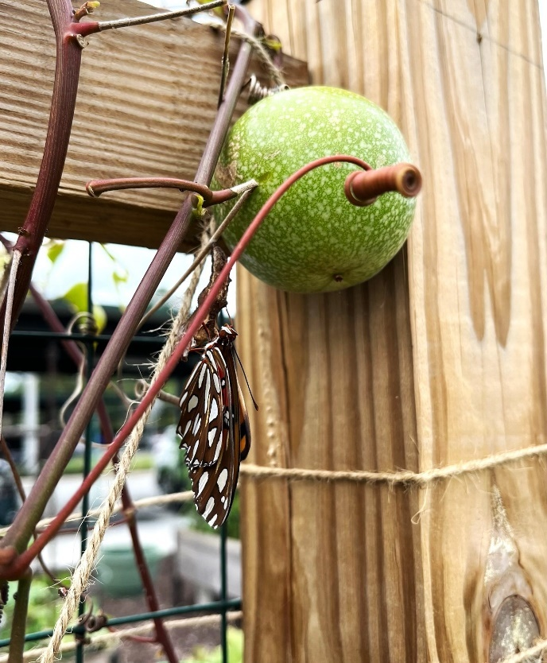

Fritillary butterfly is just emerging from its chrysalis. The chrysalis is attached to the trellis in the ‘raised’ garden beds. The trellis is supporting a Passion vine. The green ball in the picture is an immature passion fruit. The photo was taken by Alan Lesnik who was fortunate to be at the right place at the right time. The commentary is by Kathryn Mennella

Gardening on your balcony
Many Legacy Pointe residents would like to grow something but do not want to garden outside. So, the Gardener’s Corner will try to offer suggestions for things you can grow on your balcony.
If you are new to gardening let’s start off easy. How about a tomato plant, a pepper plant, 2 green bean plants, and some lettuce plants.

Starting time is the first week of January.
Here is what you will need.
- Several small dixie cups with a couple of drainage holes in the bottom.
- A small container of potting soil.
- A tray or baking pan to set the dixie cups into.
- Seeds for the following: 2 for peppers and 2 for grape tomatoes.
- Four seeds for the following - green beans.
- Four to Six seeds for the lettuce (depending on the kind of lettuce you like).
- Some type of spray bottle.
That is all you need to get started.
Fill each dixie cup ¾ to the top with potting soil.
Put 2 seeds in each cup ex: 2 pepper seeds in one cup, 2 tomato seeds in one cup, 2 green bean seeds in each of 2 cups, all seeds for lettuce in one cup.
Water from your spray bottle. Keep soil moist but not wet.
Find the sunniest spot on your balcony and set your tray down.
Cover at night if it gets cold. Check the soil daily to see if it needs to be sprayed with water.
You do not need a ‘grow light’.
Potting soil and garden can be purchased at ACE hardware with soil in smaller containers and more reasonably priced X.
NOTE do not go out and buy seeds. Garden club members will lend you seeds.
Contact Frank Russo at 407-341-7622 to ask for help and seeds.

Here is what you will need near the end of January. (DO NOT SPEND MUCH MONEY)
You will need a large pot to transfer seedlings. (Buy buckets at Dollar Tree based on the number of seeds you are transplanting. These cost $1.25 each versus what you would spend at a nursery which could cost $10 each. Punch 3 holes in the bottom of each bucket for drainage and you have your pot for growing each of your plants. More instructions in January L.P. Independent Times.

More Fun Recipes for Grilled Cheese continued

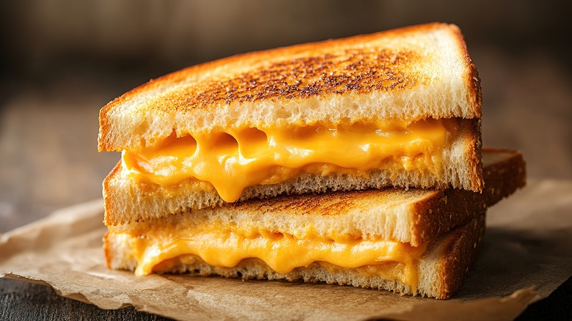

What could be easier than a Grilled Cheese Sandwich?
Cooking Tips by Frank Russo

Last month we found out some different ways to make your grilled cheese sandwich. We found out the following:
- Sprinkle salt in your pan before starting and you can also add herbs.
- Instead of butter or oil use Mayo on the bottom sides of your bread. (It keeps the bread moist as it cooks slowly, toasting the bread without letting it burn).
- Any soft cheese (or thin sliced block cheddar) will do fine.

Here is one recipe from Frank
The Bread – I use whole wheat 12 grain bread
The Cheese – 2 American Slices work fine but I also add mozzarella,
The Fillings #1 – Apple - use some thin slices let dry on a paper towel before adding. Also add some celery seeds or sunflower kernels for a crunch.
OR
The Fillings #2 Tomatoes and Spinach. Slice tomatoes thin let dry on paper towel along with the spinach. Add some cooked bacon or bacon bits.
Start with a cold fry pan (I use cast iron by a company called Lodge). Put first slice of bread – mayo side down directly in pan. Add on bread a slice of cheese and lightly sprinkle the celery seeds and/or sunflower on top then add the sliced apples, Sprinkle a little mozzarella, add the second slice of American and add the second slice of bread. Coat the top side of the bread with Mayo and you are ready to cook.

The Heat – Start cold and slow heat around 350 and do not keep pressing on the bread as it cooks. With the fry pan uncovered, toast the bottom side for about five minutes until brown. During this stage, it's important to avoid pushing your sandwich around on the pan, which will only delay browning.
FLIP the sandwich over and brown for around 3 - 4 minutes (Flipping is an art – I use 2 spatulas. I am not always successful and end up a little messy).
Cover your pan. Cook on each side for another minute or two. This will melt the cheese. And you should have a crunchy golden-brown sandwich.



Next month: How about we try some ‘French Toast”

For January edition on French Toast
Why would you ever need a recipe for ‘French toast’. It is easy! A couple of eggs, some sliced bread, a little milk or cream, a fry pan and some maple syrup. And after 5 minutes you have French toast. Well yes, but how boring?
First, be adventuresome. Decide “Do I want a ‘French toast sandwich’, or French toast muffins, or stuffed French toast, or overnight French Toast or Hong Kong French toast?”

SOCIAL, PHYSICAL, & NUTRITIONAL ASPECTS OF “SENIOR LIVING”
Shared for your interest … we do not make any claims or recommendations.
This month we are going to feature how nutrition affects our Social, Physical & Nutritional Fitness
Seniors’ Nutrition Information, Your Guide To Eating Well
Some Ways Healthy Eating Affects Physical, Mental and Social Health

  - Your Heart Health Improves. The World Health Organization (WHO) estimates over one-third …
  - Your Gut Flourishes. If thinking about the bacteria in your gut creeps you out, just imagine …
  - Your Skin May Improve. The link between diet and skin health is still not completely …
  - You Might Lose Weight. One of the most (if not ‌the‌ most) important factors in weight …
See full list on livestrong.com

DO YOU NEED TO GET OUT AND DO SOMETHING?
Do you want to take a little trip for a change of scenery? Check out these 25 suggestions for short trips from Oviedo!
https://www.orlandoweekly.com/orlando/25-easy-weekend-road-trips-from-orlando-everyone-should-do-at-least-once/Slideshow/35988297/35989533

IF YOU DON’T WANT TO LEAVE LEGACY POINTE …
Check out Kristina Ferry's weekly Activity email postings to LP residents! See also the daily/weekly Activities section in the UniGuest app.
Here are some of the many available clubs and activities to participate in:

- Arts & Crafts: Artist’s Club; Blanketeers Workshop

- Dance: Dance Club; Line Dancing

- Exercise: Aqua Aerobics; Low Impact Cardio Dance; Sunrise Tai Chi; Chair Fit; Silver Sneakers; Yoga (Seated, Chair and Mat versions)

- Fun & Games: Bridge (Casual; Practice Group; Evening Group); Canasta; Chess; Game Night; Mahjong; Mexican Train Dominoes; Spade

- Gardening: Garden Club

- Literary: Book Club; Writer’s Group

- Music: Recorder (wind instrument) Class; Voices of Legacy Choir

- Veterans: Veterans Special Interest Group(s)

FYI ~ THE LP NEWSLETTER LOGO

The blue and yellow leaves represent Legacy Pointe's colors.

The green leaves (growing higher) represent the continuing growth provided by our residents.

This beautiful design was created by LP resident Jonathan Wahl.

THE LEGACY POINT BOOK CLUB

The Legacy Pointe Book Club meets on the third Tuesday of the month at 3 PM in the Card Room

Our Book for December is called: The Four Agreements by Don Miguel Ruiz



n The Four Agreements, don Miguel Ruiz reveals the source of self-limiting beliefs that rob us of joy and create needless suffering. Based on ancient Toltec wisdom, The Four Agreements offer a powerful code of conduct that can rapidly transform our lives to a new experience of freedom, true happiness, and love.
- A New York Times bestseller for over a decade
An international bestseller published in 52 languages worldwide

Our Book for January 21st is called: The Samurai Garden – Gail Tsukiyama
From Amazon reviews
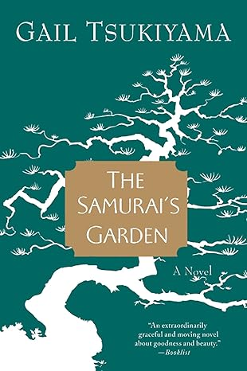
The daughter of a Chinese mother and a Japanese father, Gail Tsukiyama's The Samurai's Garden uses the Japanese invasion of China during the late 1930s as a somber backdrop for this extraordinary story.
A 20-year-old Chinese painter named Stephen is sent to his family's summer home in a Japanese coastal village to recover from a bout with tuberculosis. Here he is cared for by Matsu, a reticent housekeeper and a master gardener. Over the course of a remarkable year, Stephen learns Matsu's secret and gains not only physical strength, but also profound spiritual insight.
Matsu is a samurai of the soul, a man devoted to doing good and finding beauty in a cruel and arbitrary world, and Stephen is a noble student, learning to appreciate Matsu's generous and nurturing way of life and to love Matsu's soulmate, gentle Sachi, a woman afflicted with leprosy.
The daughter of a Chinese mother and a Japanese father, Gail Tsukiyama's The Samurai's Garden uses the Japanese invasion of China during the late 1930s as a somber backdrop for this extraordinary story.
A 20-year-old Chinese painter named Stephen is sent to his family's summer home in a Japanese coastal village to recover from a bout with tuberculosis. Here he is cared for by Matsu, a reticent housekeeper and a master gardener. Over the course of a remarkable year, Stephen learns Matsu's secret and gains not only physical strength, but also profound spiritual insight.
Matsu is a samurai of the soul, a man devoted to doing good and finding beauty in a cruel and arbitrary world, and Stephen is a noble student, learning to appreciate Matsu's generous and nurturing way of life and to love Matsu's soulmate, gentle Sachi, a woman afflicted with leprosy.

SURFING THE INTERNET

You could spend your whole day just sitting and surfing. If you do this your entire body will fall apart from lack of exercise. So, our newsletter is asking its readers who spend just a few minutes a day surfing to send along some links to articles that may be interesting or funny or extremely important. Send links to Frank Russo at frankrusso2012@gmail.com

Here is an interesting article on saving for retirement. The article is really an ad but contains interesting numbers which correspond to the figures that Vanguard and other companies have reported.
Can You Guess How Many Americans Successfully Retire With $1 Million Saved? The Percentage May Shock You

The author from Benzinga Money, states that “A startling 37% of retirees report having no retirement savings, an increase from 30% in 2022”. But worse still: “71% are carry non-mortgage debt averaging $19,888”.

Read the link below for more. NOTE it is not an endorsement of their products.
https://www.benzinga.com/money/1milsaved?utm_campaign=partner_feed&utm_source=yahooFinance&utm_medium=partner_feed&utm_content=site&nid=42141974

Feedback? Stories? Photos?
Send to Frank Russo at frankrusso2012@gmail.com

SPACE LAUNCHES AT KENNEDY SPACE CENTER FOR DECEMBER


Photo by Joyce Swing

For list of all Launches check this website suggested by John Boldt.
https://nextspaceflight.com/launches/

THE LEGACY POINTE RESIDENTS FORUM

Remember to SIGN UP for the LP Residents Forum!
https://lpresidentsonline.org/smf

You can easily set up your login and password. The Forum is a place for you and your neighbors to come together . . . To create a knowledge base . . . To go beyond a community to becoming a family. We hope to see you online soon. If you need help, email Forum Administrators Jonathan Wahl 47ipsd@gmail.com or Ina Hunt utgrad@attglobal.net

And in case you missed any issues, click the following link to access the complete Newsletter Archive: LP Residents Forum - Residents Newsletters (lpresidentsonline.org)

Please check out In Memoriam, the latest Category on your Legacy Pointe Forum. It is a place where we can express our love and memories of cherished members of our Legacy Pointe Family who are no longer with us. A place to celebrate their lives and ensure they will not be forgotten. And a place to draw comfort from our shared memories. Please feel free to share pictures, stories, memories, tributes, and obituaries. To Create a memorial, click New Topic and type the person's name. To add your sentiments to an existing memorial, click Reply.
If you have any questions please contact Forum Administrators Jonathan Wahl or Ina Hunt (email addresses above).

Sunset

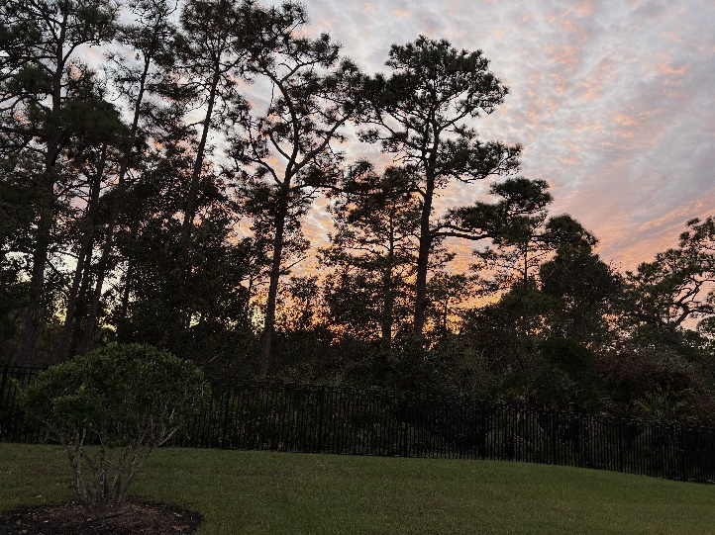

Photos by Marsha Call

OUR DAY ENDS



Super Moon by Charlie Haum

